**Task 1: Investigate the customer's environment**

Launching an Instance

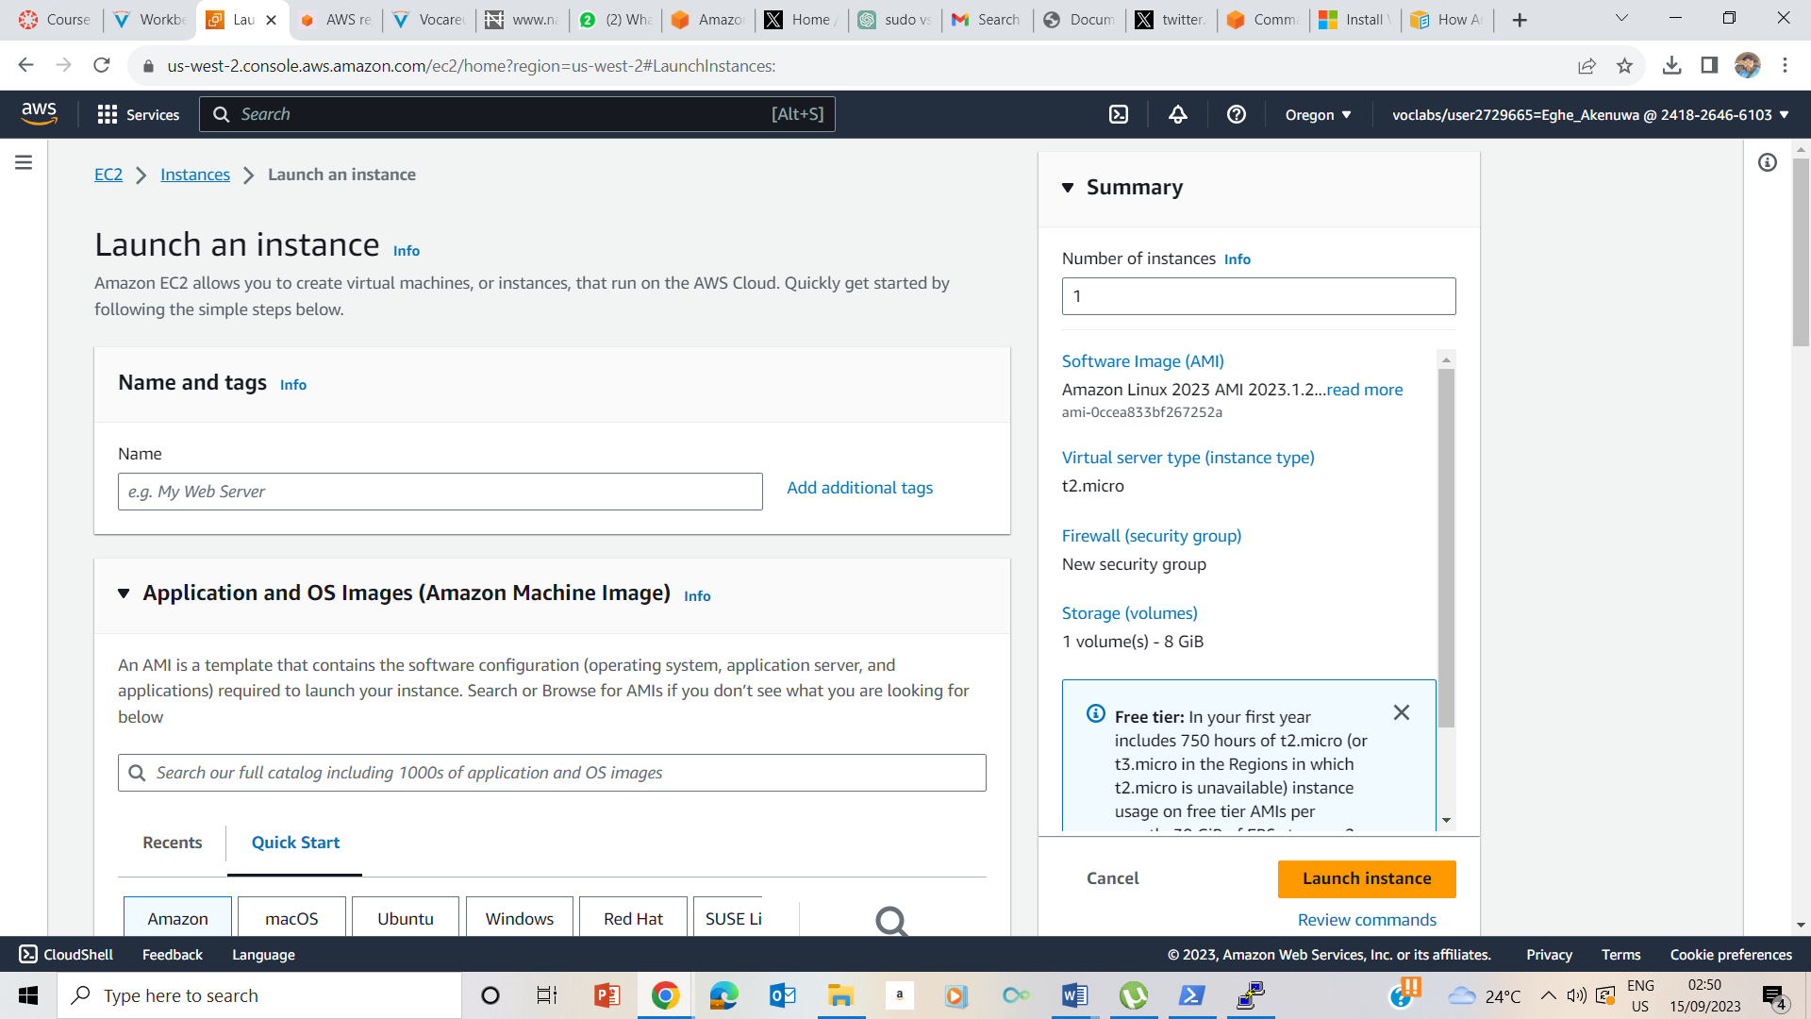

Choosing an AMI- Choosed AMAZON Linux 2 AMI (HVM)

CHOOSE t3.micro intant type

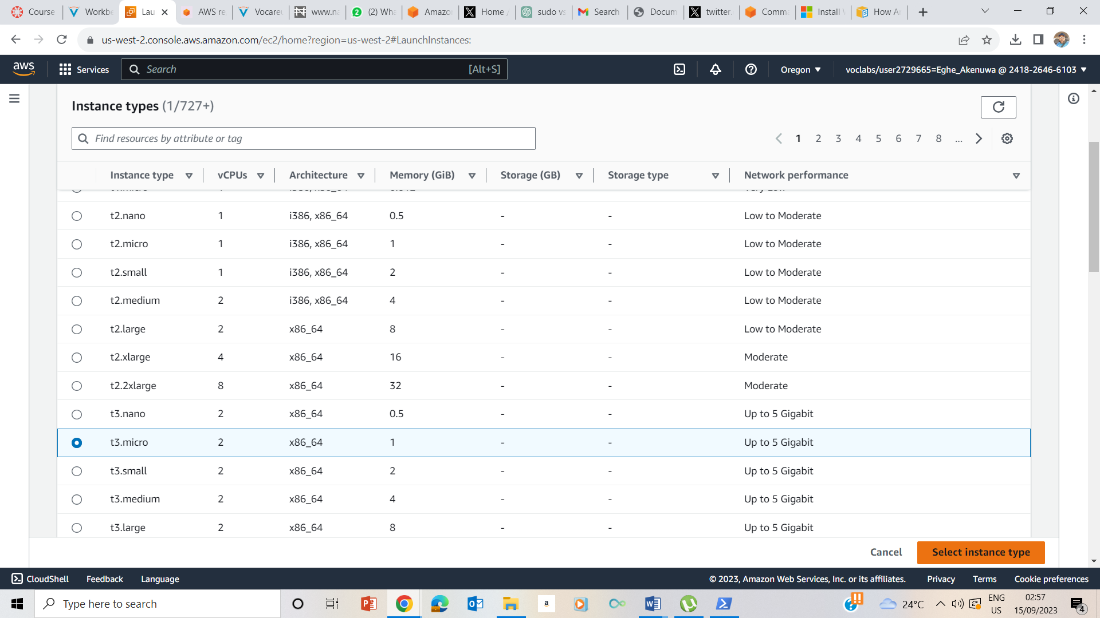

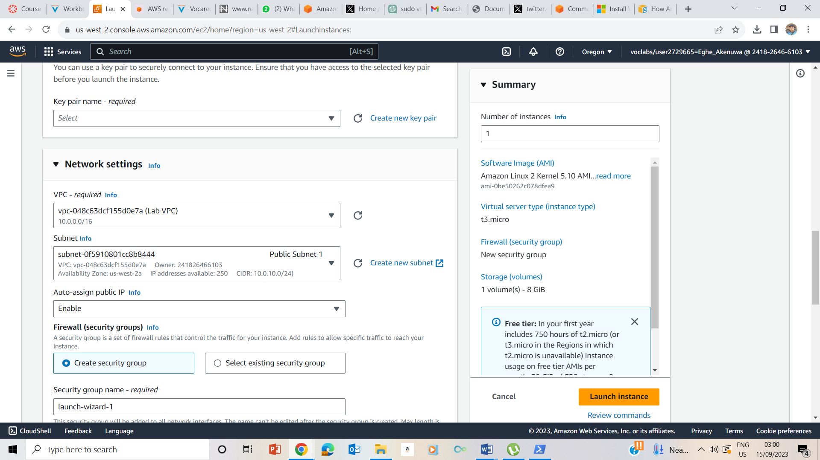

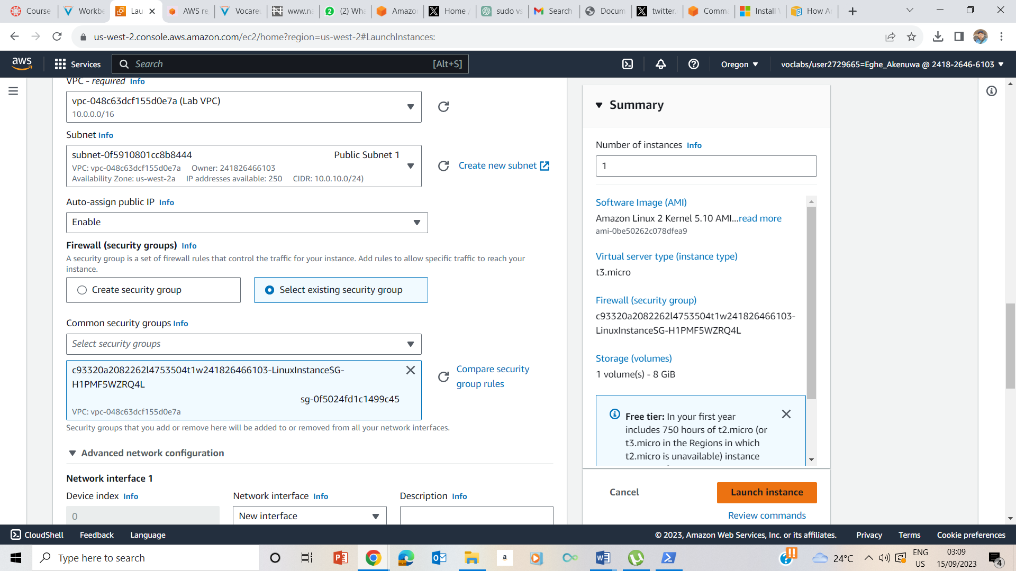

Selected Vockey key pair

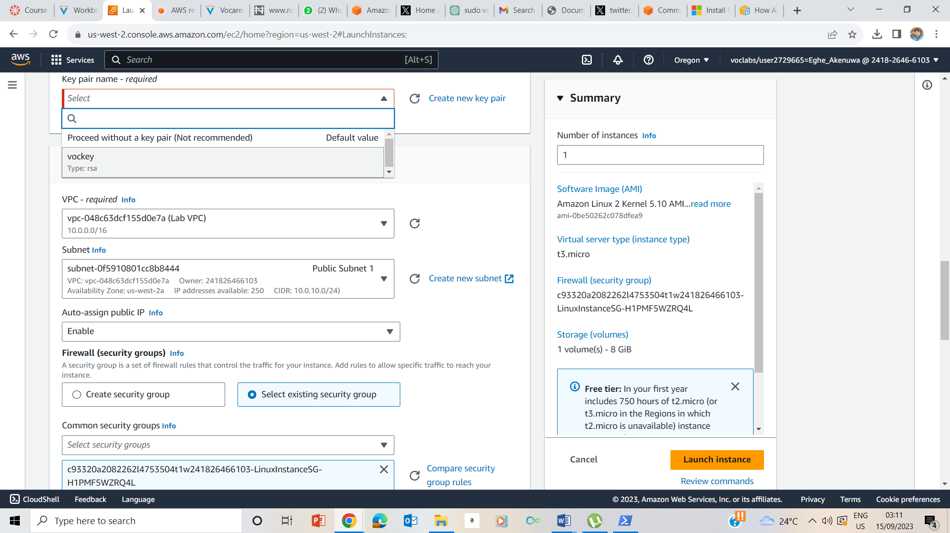

Instance successfully Launched

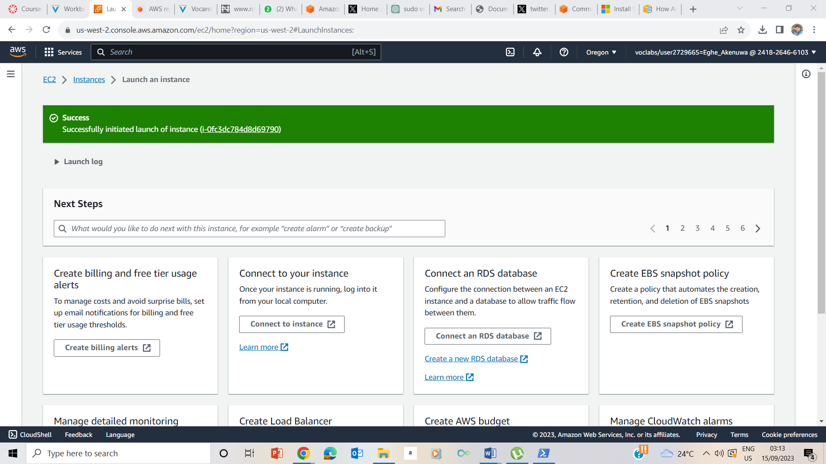

Launched test instance

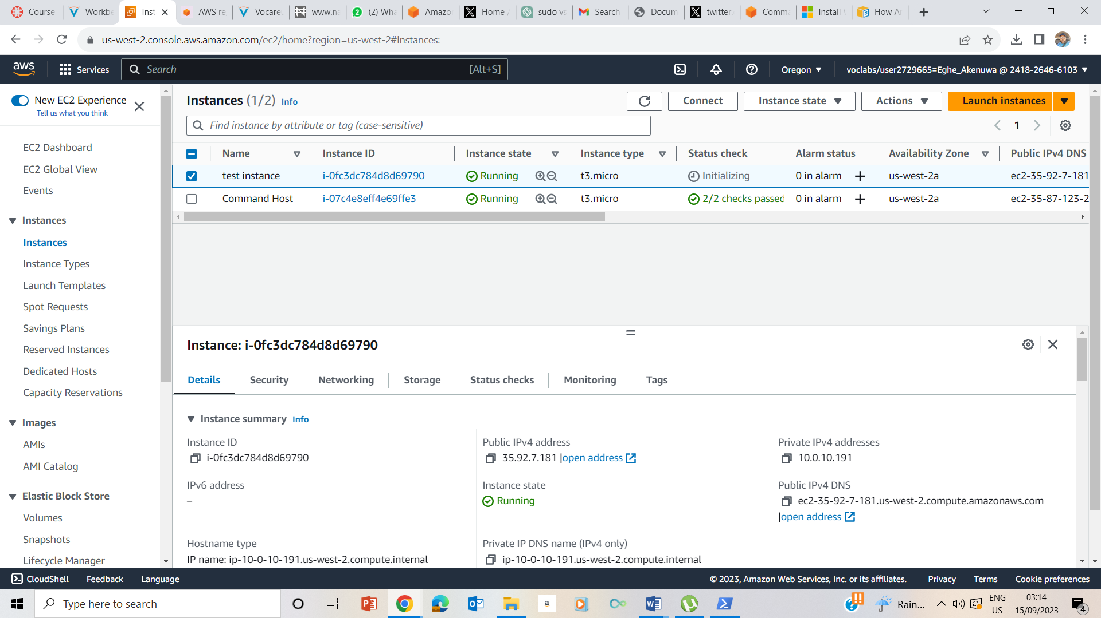

Selected the test instance and Networking

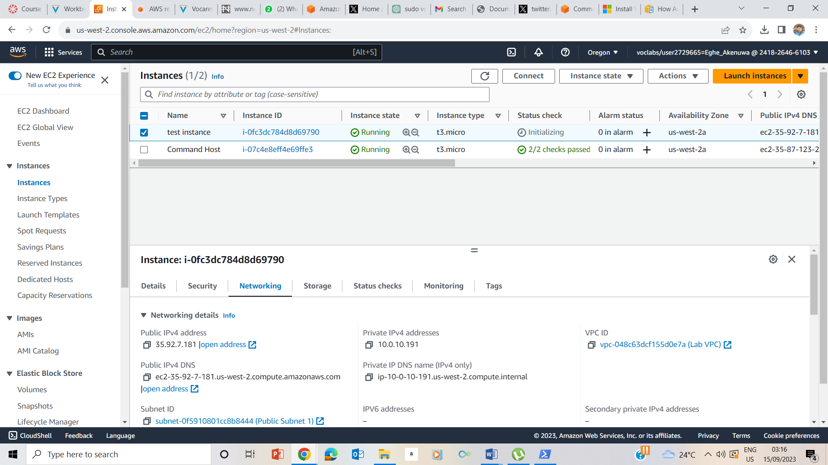

Stopping the Instance

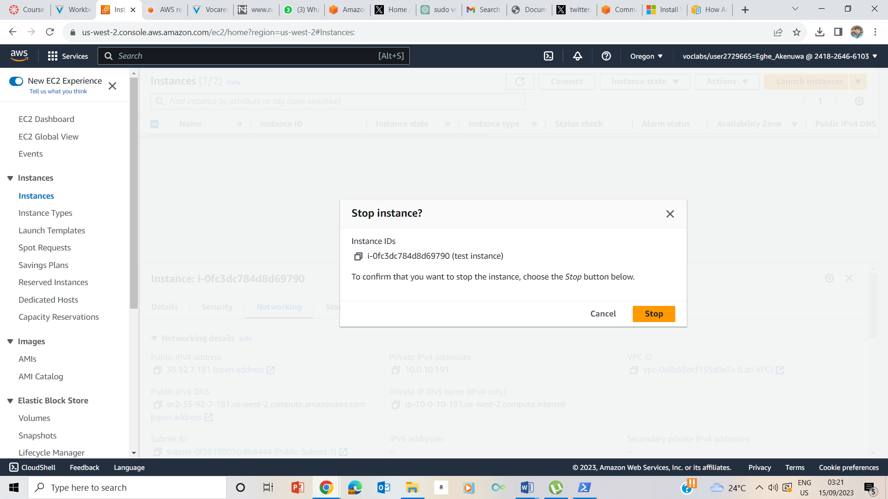

Instance Stopped

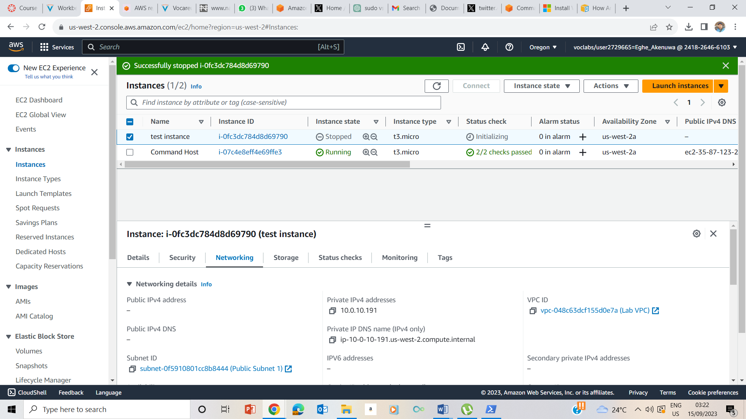

Various Instant States

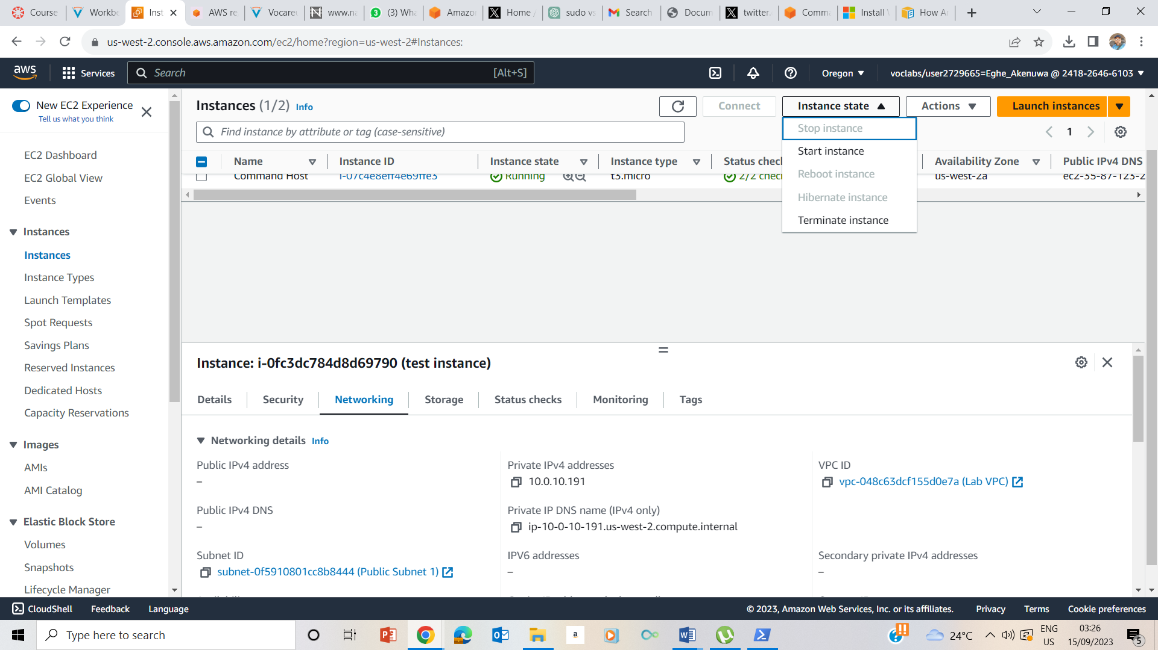

Started the Instance

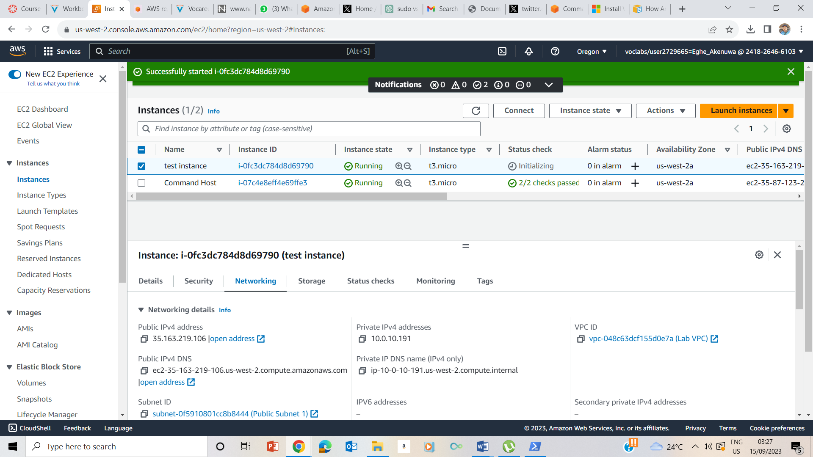

The previous public ip address was 35.92.7.181 and this new public ip address is 35.163.219.106 thus it is a dynamic public ip address while the private ip address remained same as 10.0.10.191.

Allocation of elastic ip

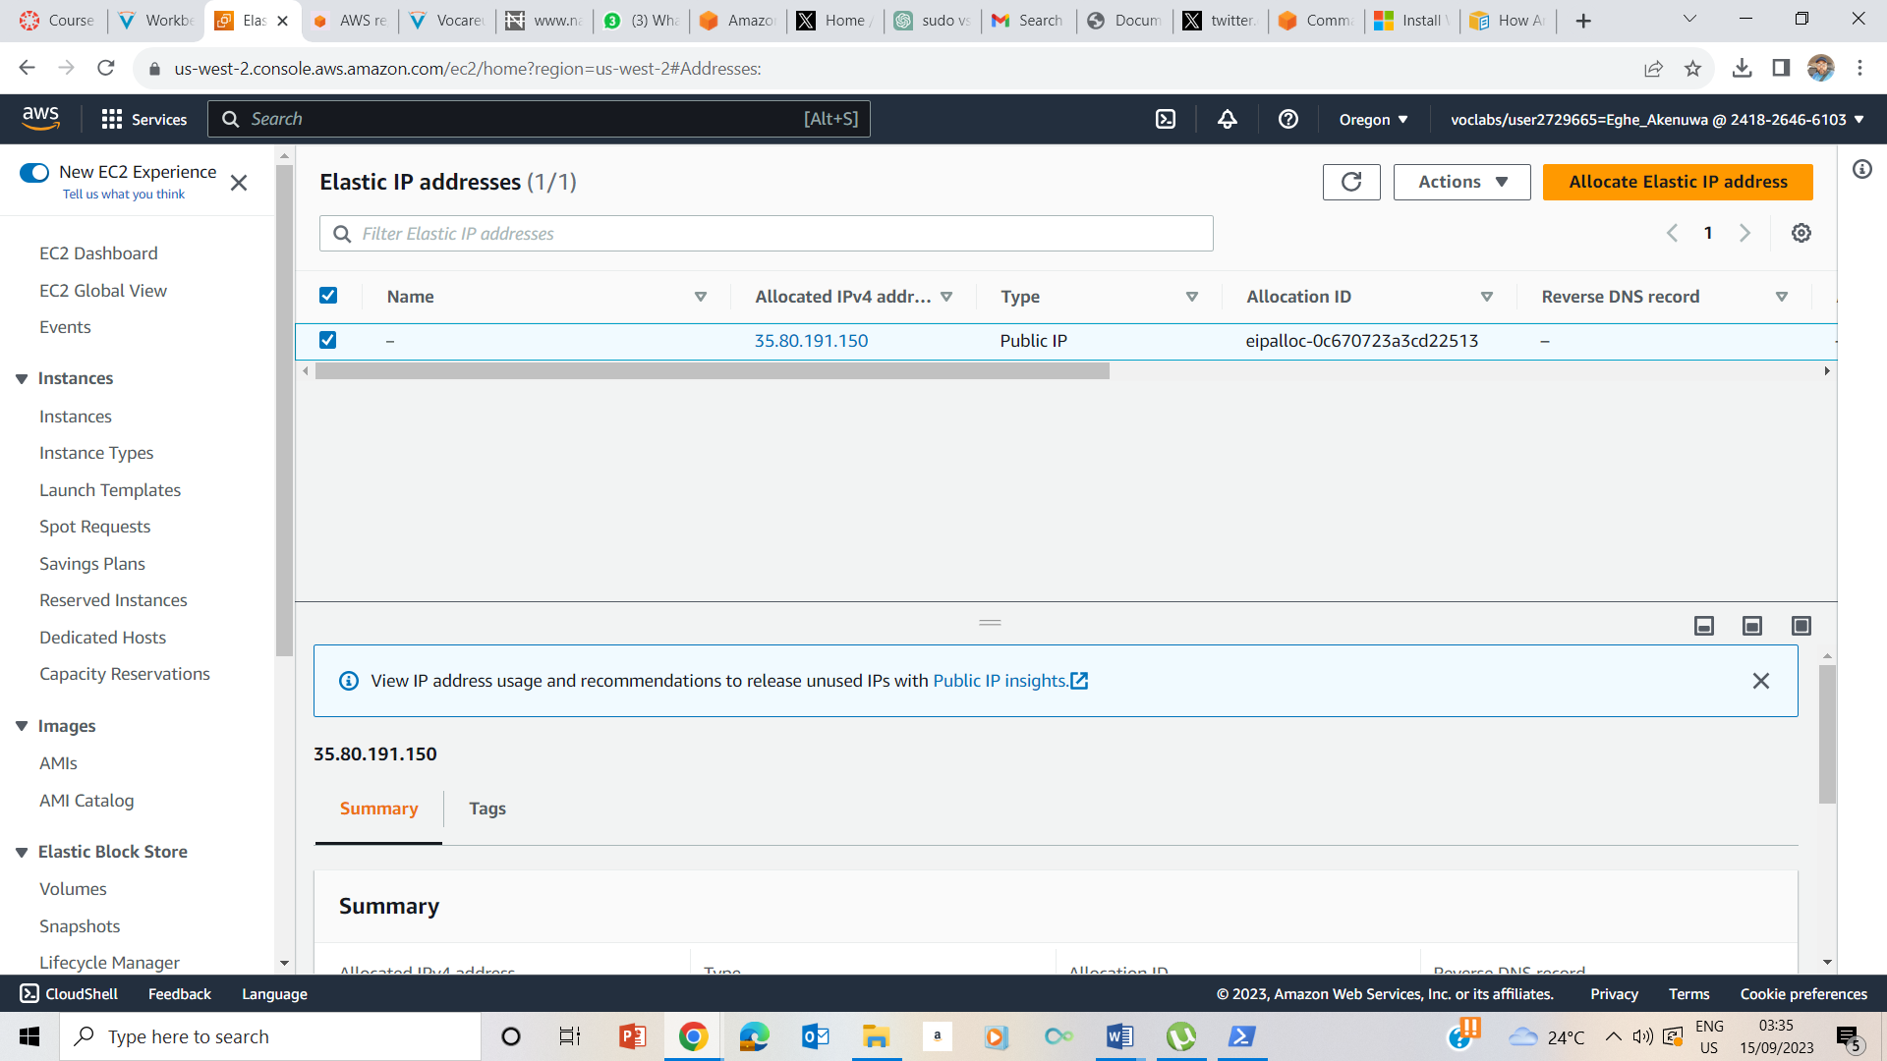

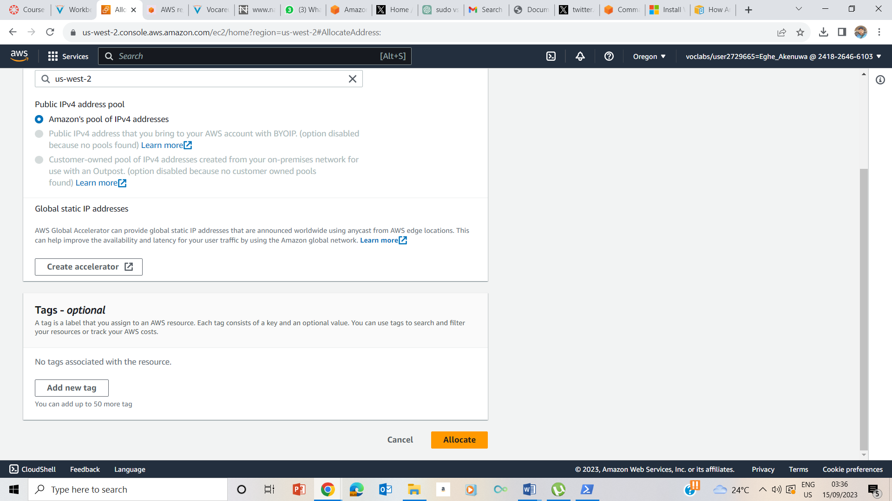

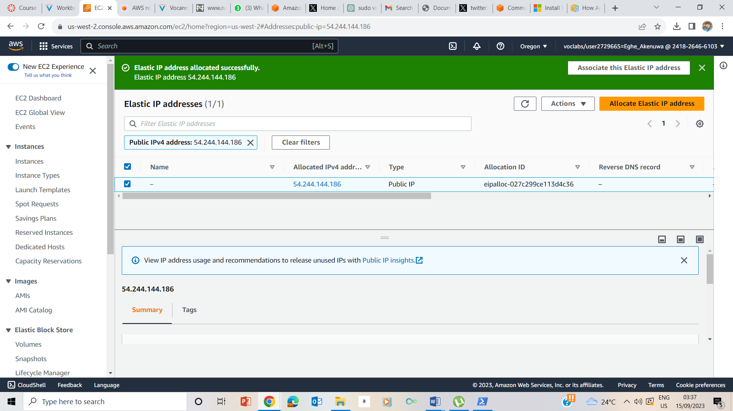

Associate the Elastic ip address

